13.18: We have Comparing this to the general form of the velocity for SHM:
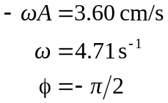
(a) 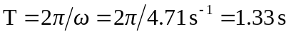
(b) 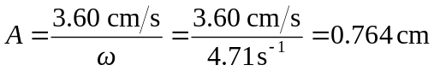
(c )

